FIRST TERMINAL EXAMINATION SEPTEMBER- 2019
Marks obtained:

Total:60
Name : _________________________
Grade : I Section ___
Subject : Hindi
Date: 26.09.19
Time : 3 Hours

I. खाली जगहों पर स्वर अक्षर लिखो।
Fill the blanks with correct swar letter. 11X1=11

अ _________ _________ _________ _________
_________ _________ ए _________
_________ _________ _________ _________ अ:
II. व्यंजन अक्षर को क्रम से लिखिए ।
Write the Vyanjan letters . 8x1=8

क ______ ______ ______ ______
______ ______ ______ ______ ञ

III.व्यंजनों को क्रम से लिखिए ।
Rearrange the Vyanjan letters: 10x1=10
ख च ज ग क
ड. ञ घ छ झ
_____ _____ _____ _____ _____
_____ _____ _____ _____ _____

IV.सही चित्र के साथ अक्षरों को जोड़िए ।
Match the letters with correct picture. 5x1=5

1. छ

2. च

3. घ

4. झ
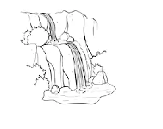

5. क

V.स्वर और व्यंजनों को अलग करके लिखिए ।
Write the Swar letters and Vyanjan letters in different box: 10x1=10

ख आ इ ग क
ड. अ घ ई उ

Swar letters
_____ _____ _____ _____ _____

Vyanjan letters
_____ _____ _____ _____ _____

VI .चित्र का पहला अक्षर लिखिए ।
Write the first letter of the picture. 5x1=5

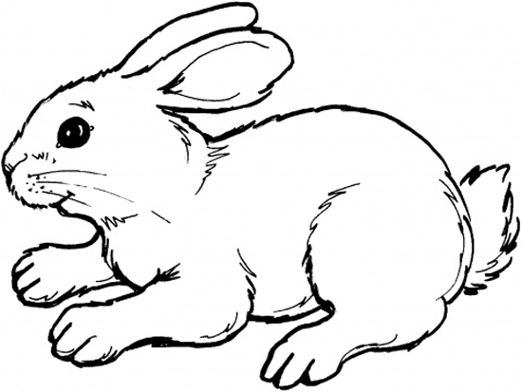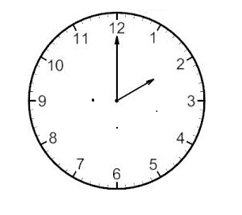

- ___________ 2. __________

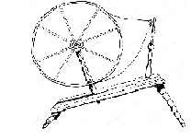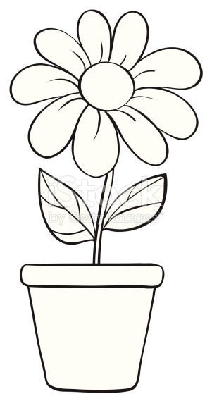
3.______________ 4. ___________

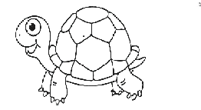

5. ___________
VII.Colour the correct picture. 6x1=6
सही चित्र मे रंग भरो ।
1.आम

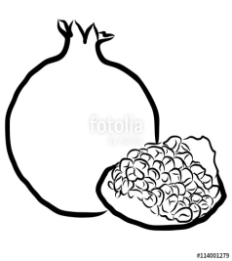
- अनार

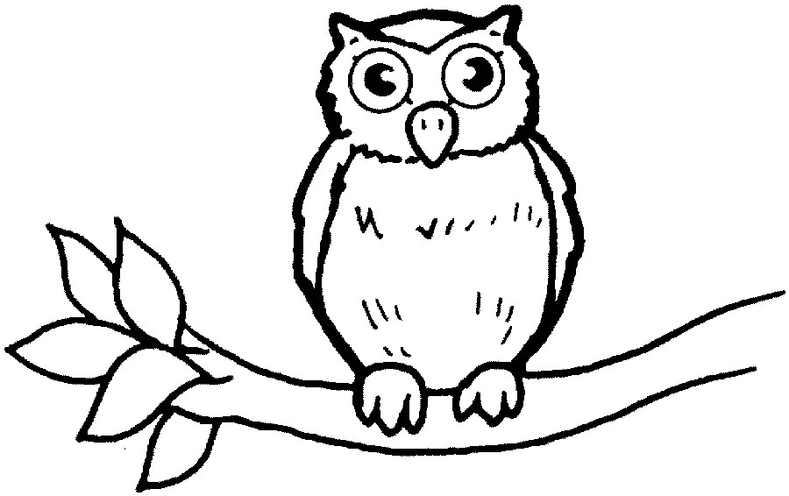
- उल्लू

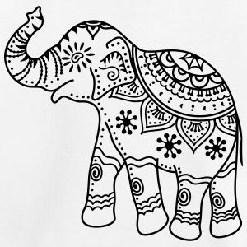
- ऐरावत

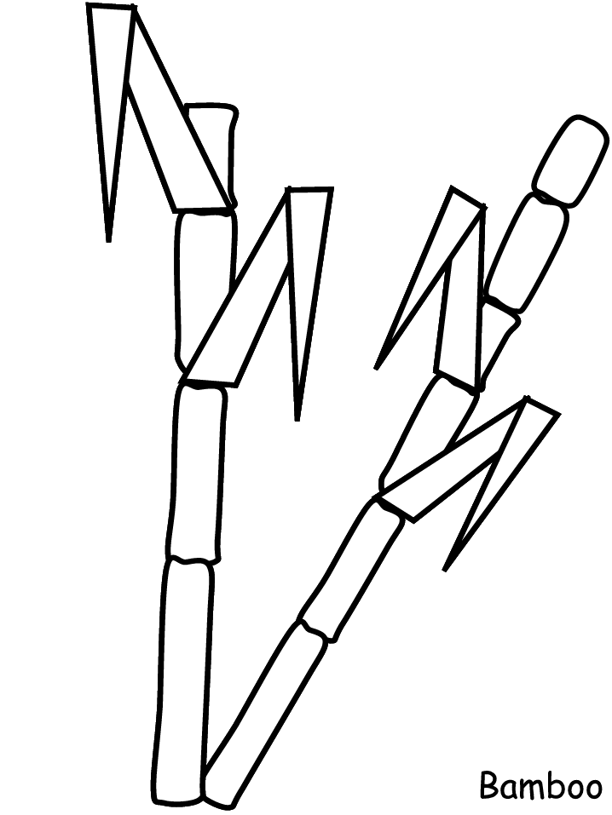
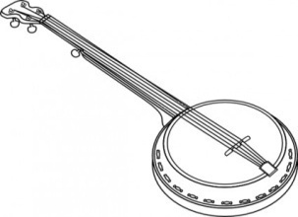
- ऊन

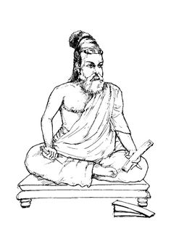
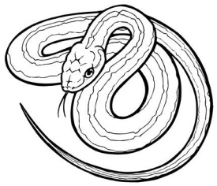
- ॠषि

VIII. Orals 5
मौखिक

Grade III

- Write the swar or Vowels (

II. Fill the blanks with correct VyanjanOr Consonants:

III.Write the English Meaning for the Hindi Words
1.
2.
3.
4.
5
- Match the correct Matrayee

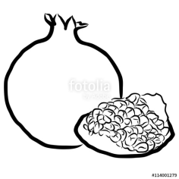

- अ

3. आ

III. Choose the letters from the brackets and write (अ, आ,इ, ई, उ,) 5x1=5
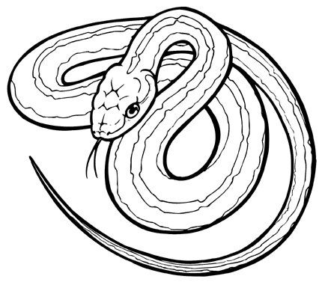
1.___________

2. ___________

3.____________

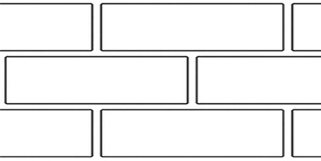
4.____________

5.___________

IV. Hand writing. 2
आ ए इ ओ अ:

V. Oral Swar letters: 5

MONTHLY TEST – JUNE2019
Marks obtained:

Total:25
Name: _____________
Grade: II Section___
Subject: Hindi
Date: 25.6.19
Time:1Hour

I. Fill in the blanks with correct letter. 8X1=8

अ _______ इ ______ उ _______ ॠ

ए _______ओ ________ _________ अं

II. Fill in the blanks with correct letter. 6 x 1 = 6

क________ ग __________ ड.

च _________ ज __________ ञ

ट __________ ड__________ ण

II. Match the letter with correct picture: 5 x 1 =5

1. ई

2. आ

3. ए॓

4. उ

5.अं

IV. Hand Writing: 2
आप कान हाल पान राम
___________ _________ __________ __________ ___________

V. Oral 4

Monthly Test – June – 2019 Marks Obtained:
Name: ____________________ Total : 25
Grade: III Section: __________
Subject: 28 .6.19
Time : 1Hour
I Write the Swarअ–अ: 11x1=11
________ ________ _________ _________ __________ ________

________________ _________ _________ __________ _________
_________

II Fill in the blanks with correct Vyanjan: 8x1=8
क ________ ग __________ ड.

च _________ ज __________ ञ

ट __________ड __________ ण

त __________ द ___________ न

III Write the English Meanings for the Hindi words: 5x1=5
- कुत्ता -

- तोता -

- बिल्ली -

- कौ॑आ -

- कबूतर -

IV. Hand Writing: 1

